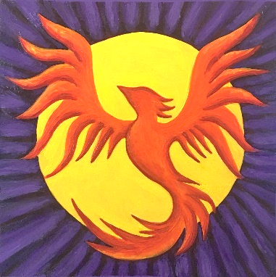

WISDOM JOURNEYS, LLC

9-Month Virtual Goddess Immersion

REGISTRATION FORM

Name (first and last) of attendee:

Attendee’s email address:

Attendee’s address:

Attendee’s phone number:

PAYMENT OPTIONS

- *(Preferred) Mail completed registration form with check made out to Wisdom Journeys LLC to: Lois LeBlanc, 800 West Lovell Road, Lovell, Maine, 049051

- By card through PayPal. You would need to request this and we will send the attendee invoice at the email address provided above.

- Email to inquire about payment plan options if needed.

PAYMENT SELECTIONS
(Price includes Certificates with NBCC contact hours upon completion)

- $2,056

- $1606 (Returning students)

